https://www.marine.ee/et/
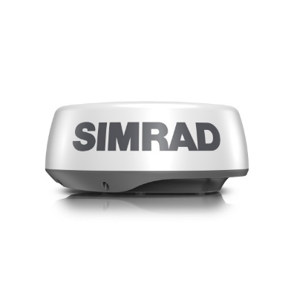

SIMRAD HALO20 Radar
2542,00 €

HALO20 Radar - A cost-effective way to increase situational awareness and collision avoidance, HALO20 is a compact pulse compression dome radar that detects collision hazards and other targets in close and up to 24 nautical miles away. Small footprint and low profile, HALO20 is the perfect radar solution for budget-conscious boaters with small sportfishing vessels and dayboats.
Tootekood
000-14537-001
Kaubamärk
Simrad Yachting

